BIOE 507 Electrochemical Sensors – Week of March 2nd Quiz 03/04/21

1. **What are the basic components of a biosensor instrumentation - Draw a simple block diagram to write 1-2 sentences explaining the components.**

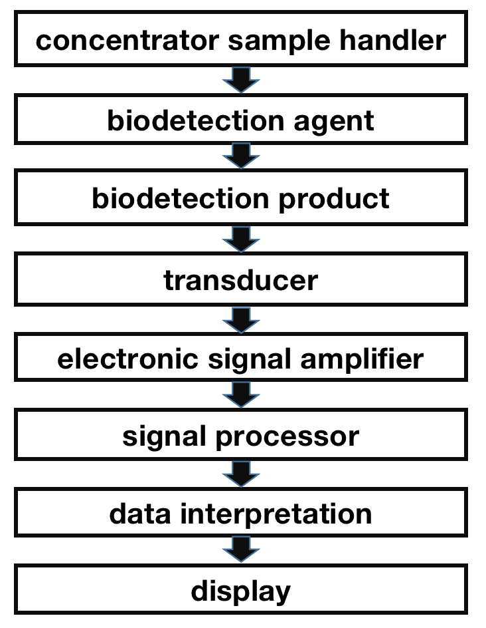

**Concentrator sample handler:** it is used to concentrate the target analyte from the sample for detecting.

**Biodetection agent:** this segment is a biological component that interacts with analyte transmitted by sample handler.

**Biodetection product:** The product generated by agent-analyte interaction in previous step whose signal could be measured by following transducer.

**Transducer:** It’s a physical component that converts the change of product concentration into corresponding electrical signals.

**Electronic signal amplifier:** to amplify the received electronic signal for further signal processing.

**Signal processor:** to conduct filtering and interpretation of the received signal data and make the strength of output signal equivalent to sample analyte concentration.

**Display**: to visualize the signal on a display for people to inspect

1. **What are the 3 broad categories of electrochemical sensors – explain the working principle in 1-2 sentences.**

**Amperometric sensors**: they measure the electric current associated with the electrons involved in oxidation/reduction reactions.

**Voltammetric sensors:** they detect analyte by measuring the change in current as a function of applied potential. They measure both current and potential.

**Potentiometric sensors:** they measure electrode potentials to determine the concentration of analytes.

1. **In Amperometry – what is the role of Oxidation potential and Reduction potential?**

The oxidation potential and reduction potential are potential at anode and cathode generated by the redox reaction involving the two electrodes and analytes. The potential difference will produce a current that is proportional to the amount of redox reactions at electrode and could be measured in the amperometric biosensor.

1. **Explain the basis of Nernst Equations. How is this used in the context of Electrochemical Sensors. What is an Equilibrium constant – what does it denote in Nerst Equation.**

The electrode potential depends on the ion concentration in the solution, while their relationship is govern by the Nernst equation.

For reaction aA+bB=2e $↔$ cC+dD, the format of the Nernst equation is E=E0-RT/nF ln [C]^c[D]^d/[A]^a[B]^b and $∆$ G=-nFE, where E0 is the standard electrode potential at 298K, R is the gas constant, T is the temperature, F is the Faraday constant, [X] is the concentration of ion, n is the number of electrons transferred in the half-reaction, $∆$ G is the change of Gibbs free energy. So it could be used for computing the free energy change of the reaction and the potential at each electrode given redox analyte concentration.

The equilibrium constant is the value of the reaction quotient [C]^c[D]^d/[A]^a[B]^b at chemical equilibrium status. $∆$ G=RT ln (Q/Keq). It can be used to compute the free energy and potential under non-standard condition without computing the G0 and E0.

1. What is purpose of a reference electrode – why is it important.

The reference electrode is to provide a stable potential relative to the solution.

In the 3-electrodes system of electrochemical cell in potentiometric biosensors, the reference electrode allows measurement of the potential of the working electrode without passing current through it, where the reduction reaction occurs at counter electrode. It could help measure working potential changes accurately at the working electrode.

1. **If you are asked to develop a pH sensor for blood monitoring –**
   1. What sensor principle would you strategize your devise around

CHEMFET (potentiometric sensor)

* 1. What format will your sensor have (wearble? Implantable? Offline etc)

Wearable. It’s non-invasive, safer and more convenient. But correlation between the PH from body fluid like sweat or saliva and blood needs to be modeled first.

* 1. Comments on the electronics that might be needed to package your sensor

1) Signal processor should be includes to amplify and filter the signals from the electrodes of PH sensor.

2) A wireless communication system should be added to receive measurement instructions and send out the readings to the smartphone or PC in real-time.

3) Power supply system to support the working of the system.